**EXPERIMENT 2**

|  |  |
| --- | --- |
| **Name: Shivam Bhosle** | **Roll No: 2** |
| **Subject: Computer Vision (CV)** | **Class/Batch: B-1** |
| **Date of Performance:** | **Date of Submission:** |

|  |
| --- |
| **AIM** |

**To Perform Image Histogram equalization operation.**

|  |
| --- |
| **Theory** |

The contrast of an image can be modified by manipulating its histogram. A popular method is via Histogram equalization. Here, the given histogram is manipulated such that the distribution of pixel values is evenly spread over the entire range 0 to K-1.

Histogram equalization can be done at a global or local level. In the global level the histogram of the entire image is processed whereas at the local level, the given image is subdivided and the histograms of the subdivisions (or subimages) are manipulated individually. When histogram equalization is applied locally, the procedure is called Adaptive Histogram Equalization.

The histogram of a digital image, with intensity levels between 0 and (L-1), is a function h( rk ) = nk , where rk is the kth intensity level and nk is the number of pixels in the image having that intensity level. We can also normalize the histogram by dividing it by the total number of pixels in the image. For an N x N image, we have the following definition of a normalized histogram function:

p(rk)=nk/N2

This p(rk) function is the probability of the occurrence of a pixel with the intensity level rk. Clearly,

∑p(rk)=1

The histogram of an image, as shown in the figure, consists of the x-axis representing the intensity levels rk and the y-axis denoting the h(rk) or the p(rk) functions.

The histogram of an image gives important information about the grayscale and contrast of the image. If the entire histogram of an image is centered towards the left end of the x-axis, then it implies a dark image. If the histogram is more inclined towards the right end, it signifies a white or bright image. A narrow-width histogram plot at the center of the intensity axis shows a low-contrast image, as it has a few levels of grayscale. On the other hand, an evenly distributed histogram over the entire x-axis gives a high-contrast effect to the image.

In image processing, there frequently arises the need to improve the contrast of the image. In such cases, we use an intensity transformation technique known as histogram equalization. Histogram equalization is the process of uniformly distributing the image histogram over the entire intensity axis by choosing a proper intensity transformation function. Hence, histogram equalization is an intensity transformation process.



To understand how frequency distribution can be used to represent an image.

To study the correlation between the visual quality of an image with its histogram.

**Procedure**

The experiment is designed to understand and learn the image histogram concepts.

Steps to run the experiments

**(A) Histogram:**

1. Select image from the mosaic using 'select image' option

a) Select region of the image to load it in the input image panel

2. Select one option from 'Full Image Histogram' and 'Divided Histogram'

3. Select run option to perform the operations

a) Output result will be displayed in the output panel

**(B) Processing:**

1. Select image from the mosaic using 'select image' option

a. Select region of the image to load it in the input image panel

2. Select one option from Global histogram equalization, Local histogram equalization and Filtering on histogram

3. Select the size of filter from Filtering on histogram option

**Interesting Observations**

1. Try Global histogram equalization and local histogram equalization on same image and observe the result.
2. Select different size of filters and observe the change in histograms.

**Output**

1. Full Image Histogram : 2. Sub Image Histogram :

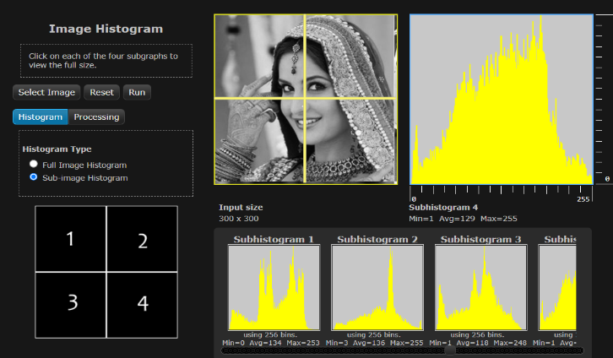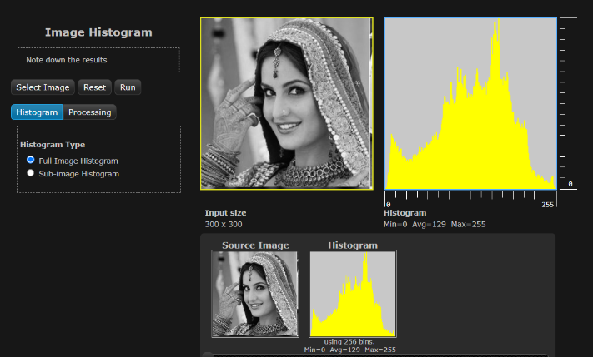

3. Global Histogram equalization : 4. Adaptive Histogram equalization (50*50)pixels :

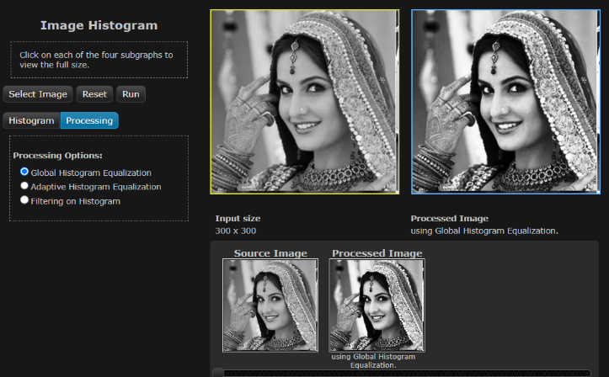

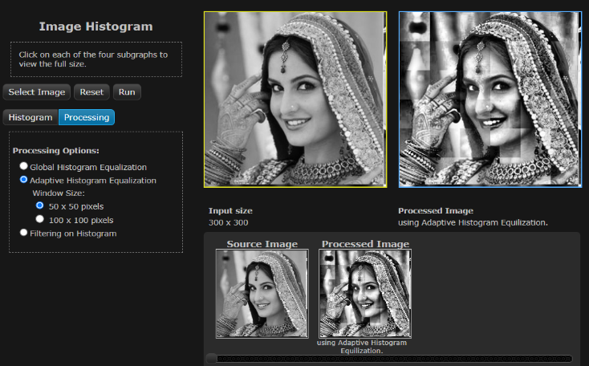

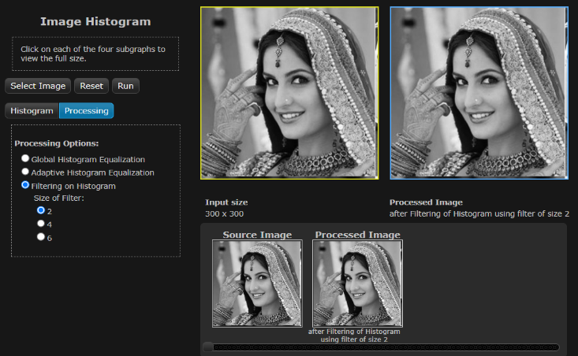5. Adaptive Histogram equalization(100*100)pixels : 6. Filtering of Histogram (2 filter) :

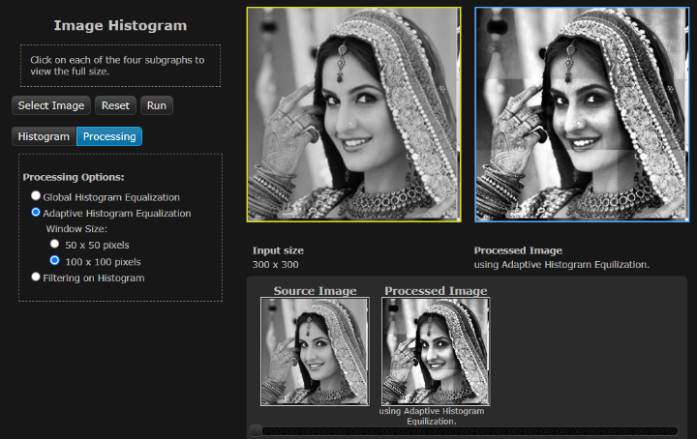

7. Filtering of Histogram (4 filter) : 8. Filtering of Histogram (6 filter) :

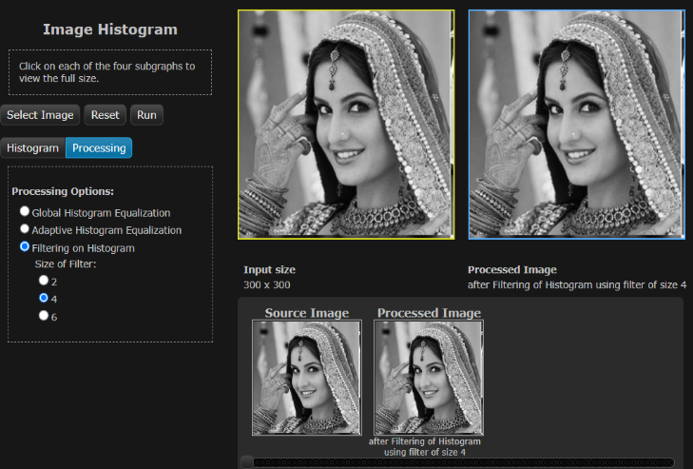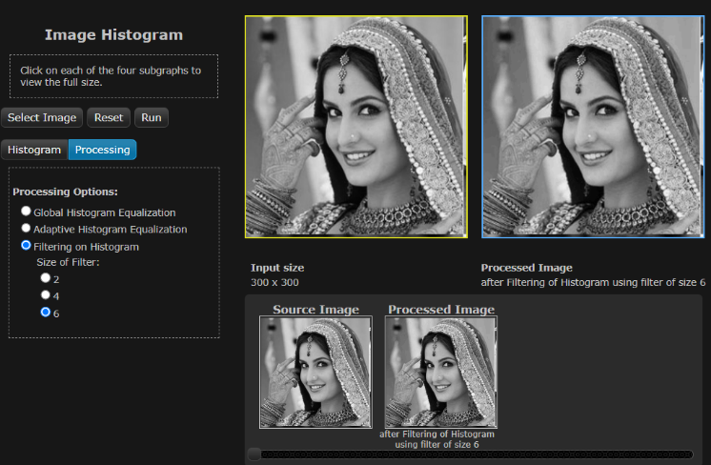

|  |
| --- |
| **Conclusion** |

Hence we have understood how frequency distribution can be used to represent an image and

studied the correlation between the visual quality of an image with its histogram.

|  |
| --- |
| **Assessment** |

|  |  |  |  |  |
| --- | --- | --- | --- | --- |
| **Timely Submission**  **(7)** | **Presentation**  **(06)** | **Understanding**  **(12)** | **Total**  **(25)** | **Sign** |
|  |  |  |  |  |